

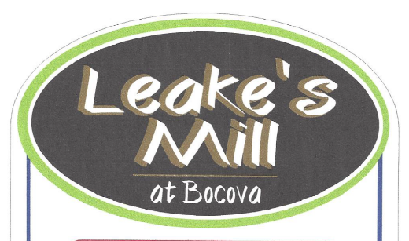

Price List

The Winslow- 2941 sq. ft. finished, 553 sq. ft. garage…………………………..........$529,950

The Jackson - 2909 sq. ft. finished, 519 sq. ft. garage
719 sq. ft. 3rd floor unfinished full bathroom rough-in...........................$539,950

The Westmoreland - 3032 sq. ft. finished, 507sq. ft. garage
587 sq. ft. 3rd floor unfinished full bathroom rough-in........$539,950

The Powell - 3045 sq. ft. finished, 495 sq. ft. garage
646 sq. ft. 3rd floor unfinished ½ bathroom rough-in........................$544,950

The Easton- 3143 sq. ft. finished, 468 sq. ft. garage
649 sq. ft. 3rd floor unfinished ½ bathroom rough-in..........$544,950

The Shenandoah- 3204 sq. ft. finished, 531sq. ft. garage........................................ $544,950

*Finished 3rd Floor on Richmond, Jackson, and Westmoreland $16,750
*Finished 3rd Floor on Easton and Powell $14,250
*All plans can be customized to fit Buyers needs

9/7/18

